# Connecting the laser sensor

Start off with connecting the laser sensor optoNCDT 1402 to the RS422 port. To do so have the RS422 connector with the screws pointing up and to the left of the device. Now the top pin is pin 1 and the bottom pin 5 as such. Now connect the wires in order.

|  |  |
| --- | --- |
| **optoNCDT (wire color)** | **RS422 (pin number)** |
| RX+ (green) | TXD+ (1) |
| RX- (yellow) | TXD- (2) |
| TX+ (gray) | RXD+ (3) |
| TX- (pink) | RXD- (4) |
| GND (blue) | GND (5) |

Next, the laser and the RS422 should be grounded in the power supply. To achieve this, connect a wire from the GND (5) port in the RS422 to the V- in the power supply. The RS422 adapter should look like the following.

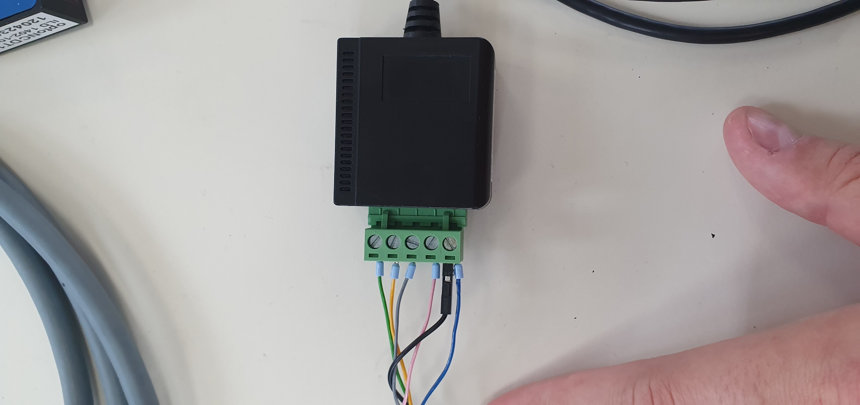

Next, the VCC (red) wire of the laser need to be connected to the power supply.

**Make sure that the power supply is not connected to the wall socket before connecting the red wire.**

Connect the red wire to the power supply V+ port.

Now it should look like this.

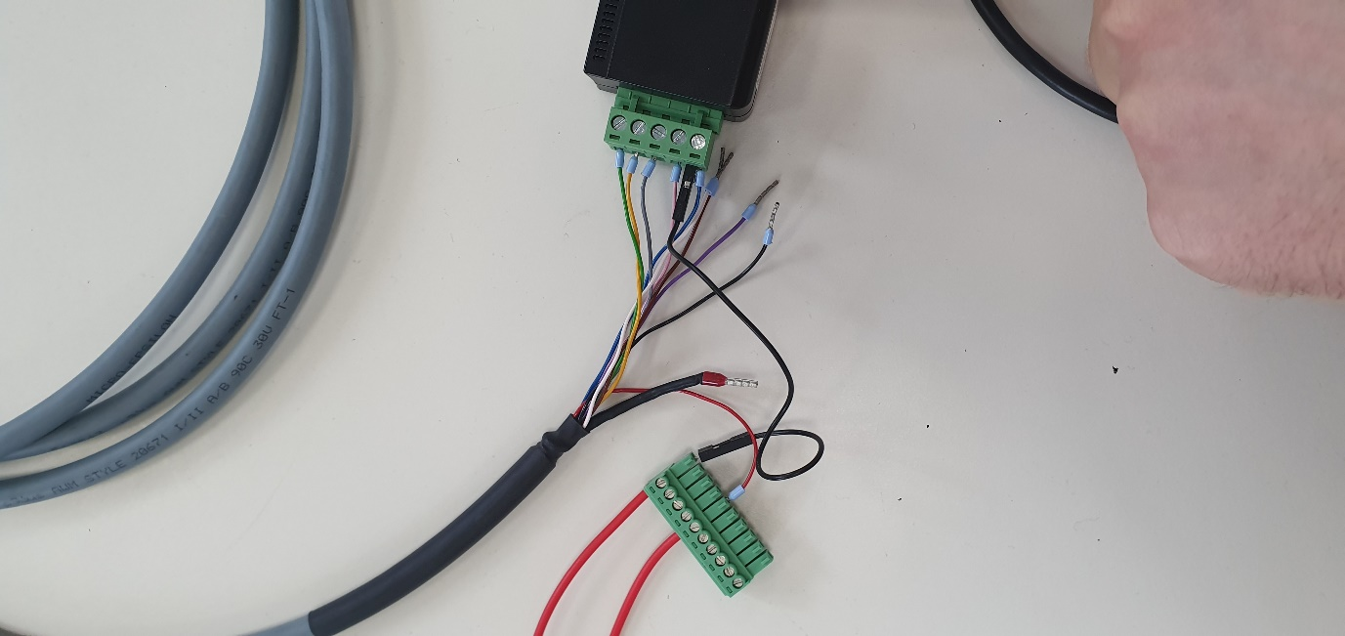

Now the power supply can be inserted in the wall socket. The laser will be off until the LaserOff (black) wire is grounded.

**Only ground the black wire of the laser when it is safe to do so. I.e when the laser sits steady and absolutely not when moving the laser. Do not at any point look into the laser.**

The schematics of the laser and the RS422 is presented below.

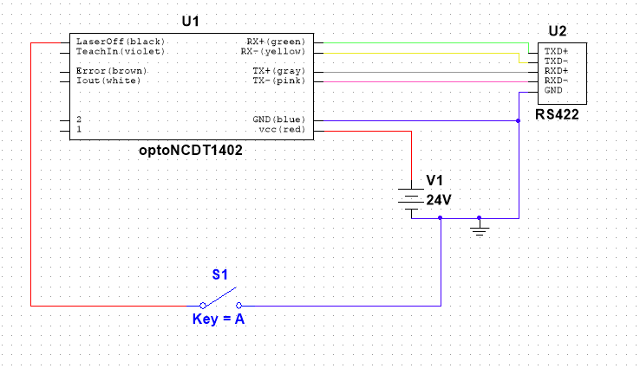

# Testing the laser with sensorTOOL

To test the laser, insert the USB-A cable in a USB port on the computer. The software used to test the sensor is sensorTOOL and can be downloaded from <https://www.micro-epsilon.com/download/software/sensorTool.exe>. After opening the program, set the sensor group to optoNCDT and the type to ILD1402 and hit the search button (the button with a magnifying glass).

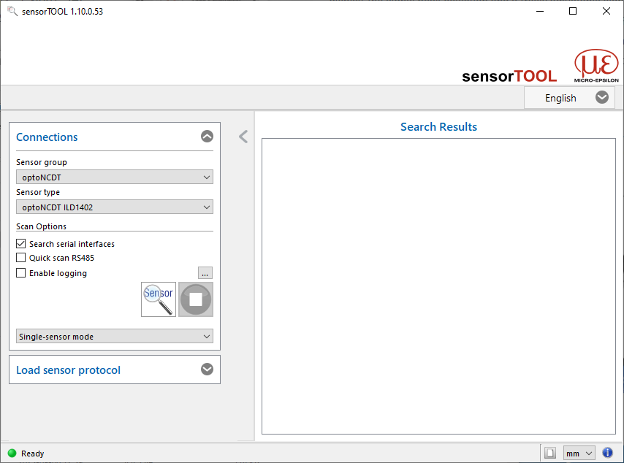

When the sensor is found, it can be tested directly in the program.

# Testing the laser with python code

When using the laser with python code, the serial library can be used. The laser output can be read in two different configurations, binary or ASCII which can be configured by writing to the sensor. The goal of reading from the sensor is to get a digital value. The value can mean different things presented below.

|  |  |
| --- | --- |
| Digital Value | Used for |
| 0… 16367 | Value range |
| 0… 160 | SMR back up |
| 161… 16207 | Measurement range |
| 16208 ... 16367 | EMR back up |
| 16370 ... 16383 | Error codes |

With the error codes

|  |  |
| --- | --- |
| Error code | Meaning |
| 16370 | no object detected |
| 16372 | too close to the sensor |
| 16374 | too far from the sensor |
| 16376 | target can not be evaluated |
| 16378 | external laser off |
| 16380 | target moves towards the sensor |
| 16382 | target moves away from sensor |
| 16383 | internal error |

## Binary

The sensor sends two binary bytes of data via serial to the computer. Each byte is eight bits long with the eight bit being a flag and the 7 after the data.

|  |  |  |  |  |  |  |  |
| --- | --- | --- | --- | --- | --- | --- | --- |
| Flag | Bit 6 | Bit 5 | Bit 4 | Bit 3 | Bit 2 | Bit 1 | Bit 0 |

Now, if the flag is 1 the byte is considered a H-Byte, if it is 0 and L-Byte. Which looks like this.

|  |  |  |  |  |  |  |  |
| --- | --- | --- | --- | --- | --- | --- | --- |
| 0 | B6 | B5 | B4 | B3 | B2 | B1 | B0 |
| 1 | B13 | B12 | B11 | B10 | B9 | B8 | B7 |

To get the output from the sensor, the data bits of the H-Byte and the L-Byte is combined to a 14 bit word as such.

|  |  |  |  |  |  |  |  |  |  |  |  |  |  |
| --- | --- | --- | --- | --- | --- | --- | --- | --- | --- | --- | --- | --- | --- |
| H-Byte | | | | | | | L-Byte | | | | | | |
| B13 | B12 | B11 | B10 | B9 | B8 | B7 | B6 | B5 | B4 | B3 | B2 | B1 | B0 |

## ASCII

When operating in ASCII mode the data is a 6 byte word consisting of ASCII code with 5 of them being the actual number and the 6th one being a “tag”. When the digital value from the sensor is less than 5 letters long, it is preceded with blank characters. It could look like this when reading the digital number 2099:

|  |  |  |  |  |  |  |
| --- | --- | --- | --- | --- | --- | --- |
| ASCII code | 0x20 | 0x32 | 0x30 | 0x39 | 0x39 | 0x0D |
| Character | Space | 2 | 0 | 9 | 9 | CR |